

Crowdfunding

Security



sUMmat college wynberg

Monday, 20 August 2018

CAT PAT: Phase 3

Keith Mdu Mwelase

**In the township of Alexandra, there are multiple security issues. From your everyday security from the police to river security. All have their flaws that need to be dealt with as soon as possible to ensure the residents of Alexandra with. Through crowdfunding, we hope to resolve these issues.**

Contents

TABLE OF FIGURES 1

Introduction 2

What is crowdfunding? 2

How to optimise a crowdfunding campaign? 2

What are the benefits of crowdfunding? 2

Launch a website 2

Plan your campaign 2

Problems in Alexandra 2

*Main Question* 2

The Report Body 3

Alexandra Township 4

Problems and Recommendations 5

Claims and Arguments 8

Sites for crowdfunding 11

Bibliography 11

# TABLE OF FIGURES

Figure 1 Aerial view of Alexandra 4

Figure 2 A highly polluted area in Alexandra 5

Figure 3 Children crossing the Jukskei river 6

Figure 4 The Criteria for success 8

# Introduction

In this phase of the PAT, my goal to research and find the necessary information to answer any questions posed in my previous two phases. My other goal to better a number of the questions as they did not sufficiently contribute to the main question in the previous phase. Along with finding the information to answer the posed questions, I will assess and determine the relevance of the information found and whether it is suitable to use in my main report. The main target for this investigation is the Government Department, State Security Agency, Environmental Health and Safety, who is responsible for the overall civilian intelligence operations.

## What is crowdfunding?

It is the practice of funding a project by raising money from a large number of people, each contributing a relatively small amount, typically via the internet.

## How to optimise a crowdfunding campaign?

Crowdfunding is hard, and certainly a great deal requires luck, but there is a way behind most successful projects. There’s a purely empirical approach to show how to optimize your video, landing page, rewards, and the optimal length of time for your campaign.

## What are the benefits of crowdfunding?

Crowdfunding can be used to great success to bring to life artistic projects, products for sale, and personal ventures like fixing up a restaurant or helping a community in need.

## Launch a website

Launching a website before starting your crowdfunding campaign is a good idea. Make sure you are already on different platforms of social media, e.g. Facebook, Twitter, Instagram, Tumblr etc.

## Plan your campaign

A lot of things can go wrong. The most important include not locking down a manufacturing process, underestimating the difficulty of scaling from a prototype, running out of money because of you’ve miscalculated the costs, and underestimating the success of a campaign, which increases the level of complications.

## Problems in Alexandra

Security is one of the biggest problems faced by the township. It has a high crime rate,

## *Main Question*

In what ways can money be raised to ensure better security in Alexandra?

# The Report Body

* Alexandra Township
* Location
* Origin
* Problems and Recommendations
* Rehabilitation of Infrastructure
* Co-ordination
* Other services
* River Banks
* Claims and Arguments
* Sites for Crowdfunding

___________________________________________________________________________

### Alexandra Township

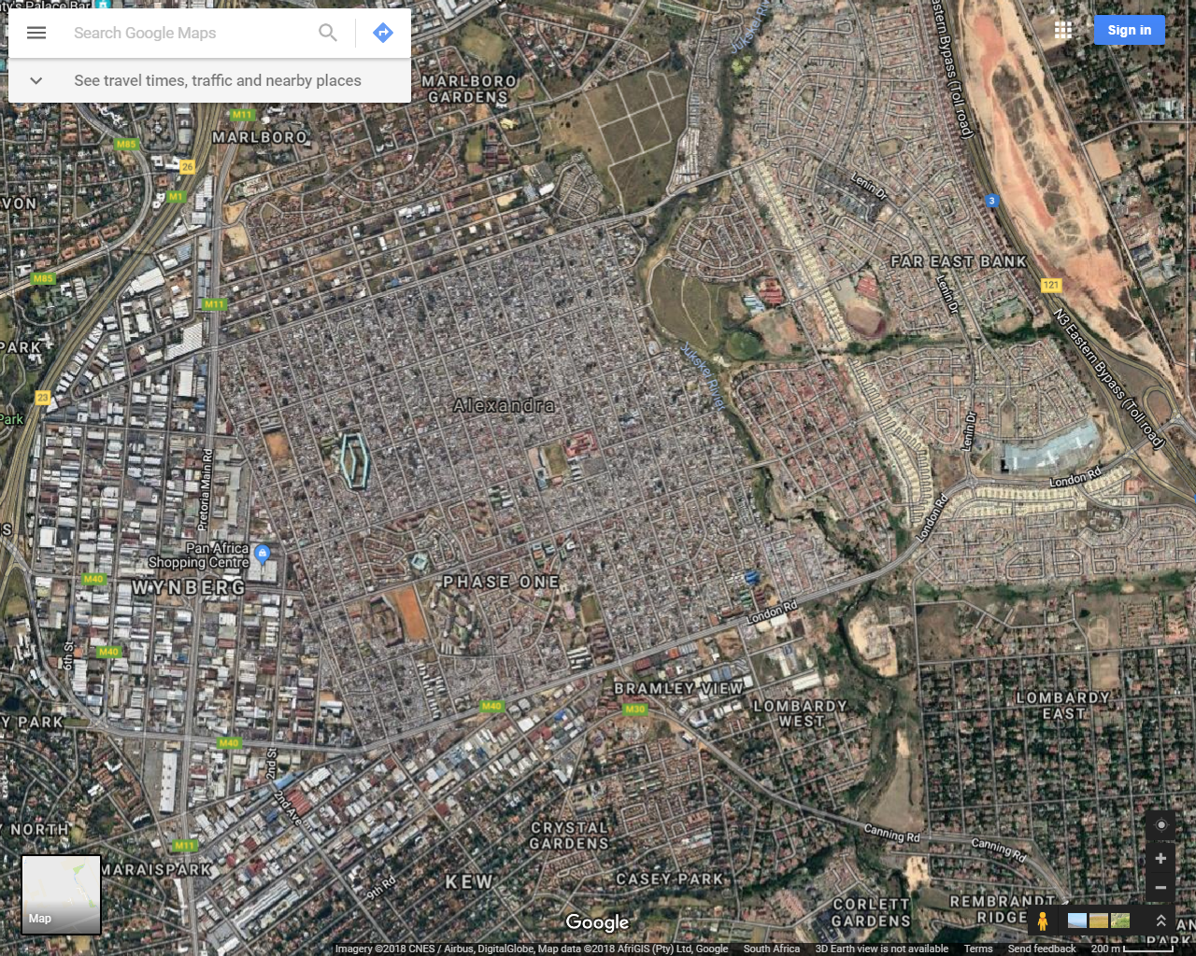

Figure 1 Aerial view of Alexandra

* **Location**

Alexandra, informally abbreviated to Alex, is a township in the Gauteng province of South Africa. It forms part of the city of Johannesburg and is located near the upper-class suburb of Sandton. Alexandra is bounded by Wynberg on the west, Marlboro and Kelvin on the north, Kew, Lombardy West and Lombardy East on the south. It is commonly known as "Gomorrah" among local residents. Alexandra is one of the poorest urban areas in the country. Alexandra is situated on the banks of the Jukskei River. In addition to its original, reasonably well-built houses, it also has a large number (estimated at more than 20,000) of informal dwellings or "shacks".

* **Origins**

The name Alexandra was the name of a farmer’s wife who in 1905 transformed his dairy farm into a township and named it after his wife.

### Problems and Recommendations

* Rehabilitation of Infrastructure: Co-ordination

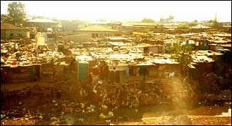

Figure 2 A highly polluted area in AlexandraProblem

**Problems**

**Categorised Responsibility**: Service planning and delivery for resources such water, sewer, roads and storm drainage, electricity, rests with a number of different departments and thus delivery can lead to inefficiencies unless there is substantial co-ordination at all stages of the project planning, budgeting and administration cycle.

**Recommendation**

**Improve Coordination Arrangements**: In planning and implementing infrastructure upgrading works covering a number of sub-sectors in heavily populated dense areas international experience has shown that planning and carrying out the works together better ensures compatibility of proposals. It enables works to be carried out more quickly, and avoids continued disruption to the beneficiary communities due to service improvements being carried out at different times.

**Involve Communities**: Recognizing the importance of the communities and involving them at key stages of project planning and implementation of upgrading initiatives further reduces the possibility of continued disruption in communities during an upgrading project. The use of contractors formed out of the community will assist in the co-ordination as well as providing employment opportunities.

* Rehabilitation of Infrastructure: Other services

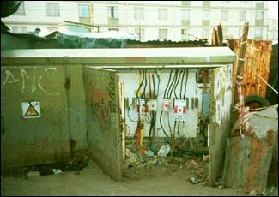

**Problem**

**Low Water Pressure:** Because of the high population there is a demand for water which exceeds system design capacity. This results in low pressures at peak times.

**Dangerous Electrical Connections:** There appear to be many illegal connections to the electricity supply system. Sub-stations are insecure and present a considerable danger to children with easy access available (e.g. doors to metal ground level units open) where it appears that “hotwiring” has occurred.

**Recommendations**

**Improvements to Water Supply Main:** Consideration is being given by GMJC to the laying of a new supply line into Alex to increase quantity and pressure and it is understood that consultants are to be appointed to plan and design a rehabilitation program. It would be important to ensure that those planning and designing sewerage system rehabilitation lease closely with those designing the water supply system rehabilitation. Ideally planning and design would be more efficient and easier to co-ordinate if carried out by the same team.

* River Banks

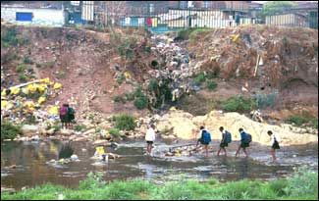

Figure 3 Children crossing the Jukskei river

**Problem**

**Informal Settlements Below Flood Line**: Many of those shacks (3000+ families) constructed along the banks of the Jukskei river are in danger in times of flood. Relocation of all those below appropriate flood lines would appear to be unavoidable.

Pollution of River: The settlements along the banks are significant polluters of the river.

**Recommendation**

**Relocate to East Bank Developments**: Those to be relocated should be resettled on the east bank, **NOT** to remote locations which would likely lead to their return along the river banks of the Jukskei river.

**Protect Cleared Areas**: As part of the relocation plan, arrangements should be put in place immediately for the areas that are cleared to protect the areas and to avoid further squatting. Recreational areas, service roads, and the proposed zonal interceptor sewer alignments are future functional uses for the west bank.

### Claims and Arguments

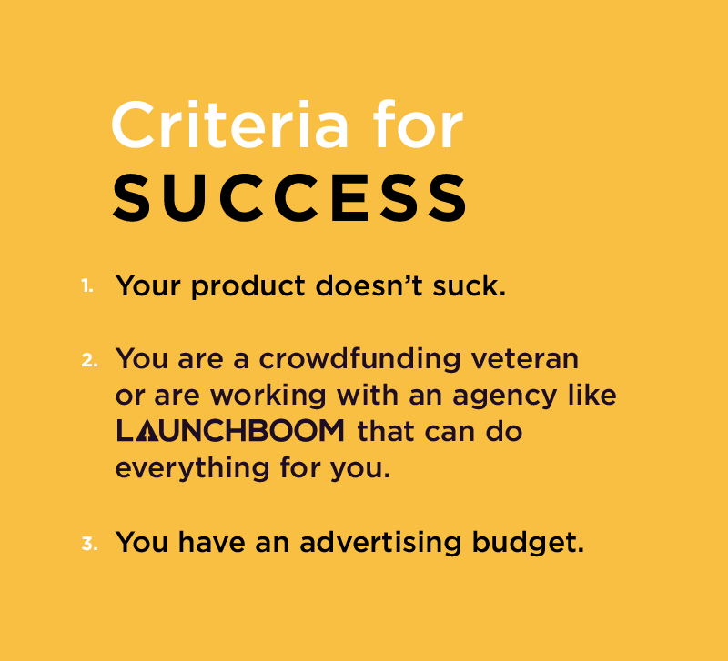

Figure 4 The Criteria for success

#### Reasons to avoid Crowdfunding

1. **Crowdfunding works best for projects that require relatively small amounts of capital**

This method of raising money may prove inadequate for larger ventures requiring millions of dollars’ worth of financing, although it can be done. It doesn't happen often and can be quite challenging. Serious, established businesses should look for other methods of funding. Making a product and distributing it involves costs. It's easier to make wire transfer payments.

1. **Lack of prestige**

While it may be hip for artists and film makers to raise capital in a trendy, technology-driven way, professionals including physicians, doctors, lawyers and others likely would not want it to be known that they posted their business plans online in search of funding.

1. **Negative impact on future financing options.**

Companies that issue shares through crowdsourcing ultimately are beholden to large numbers of unsophisticated investors who own tiny stakes in the business. This structure could deter venture capitalists or angel investors leery of investing in a firm that is owned by thousands of inexperienced shareholders.

1. **The value of shares sold to investors during a 12-month period cannot exceed 1 million USD (13’424’300,00 ZAR)**

If an entrepreneur raises $1 million or more through equity crowdfunding, he/she cannot look for additional funding for one year. Otherwise, the business owner must comply with securities registration requirements.

1. **What if your project is not "sexy"?**

While it may be appealing to artistic-minded investors to fund art exhibitions or documentary films, online support for a traditional business's working capital needs will likely be boring. In these occasions, companies are better off securing lines of credit or merchant cash advances.

1. **Speed**

If a business owner needs a lot of money quickly to take advantage of a discount deal on inventory or requires a rapid infusion of cash for a building project, he may not be able to wait for the idea to catch fire on a crowdfunding site. A cash advance or business loan from a bank are better options to make it happen.

1. **Potential lawsuits**

Investors are always expecting returns and some may not be patient a company is not making any profits. Lawsuits arising from unsuccessful business ventures can happen. Complainant may accuse the entrepreneur of things such as fraud, breach of contract or mismanagement. In consideration of the investment relatively involving small amounts of money, it may be prohibited for investor to pursue a lawsuit. The investors can file complaints regulatory enforcement agencies that may lead to government investigations.

#### Reasons Why Crowdfunding Is the Best Way to Launch Your New Product

1. **Tap into a HUGE marketplace that is growing exponentially every year and attract new customers at a fraction of the cost**

They are vibrant communities filled with potential customers. Most investors want a discount for the product they are investing in. Not only will you see a great cost per acquisition in your marketing efforts, the platform itself will promote your success and drive additional traffic for no additional cost. They are always expecting positive results.

Most tend to share your story with their friends on social media, by that, they heightening the morality of the campaign and value of each customer. They are basically receiving free campaign advertising therefore your marketing product goes further.

1. **Validate a new product and improve it with customer feedback**

According to the Council of American Survey Research Association:

“US businesses alone spend 6.7 billion dollars each year on market research and 18.9 billion worldwide**.”**

Crowdfunding campaigns are a low risk and low cost way to do market research and prove product growth while seeing some serious revenue in the process. Customers usually ask that lead to product breakthroughs. The nice thing about crowdfunding is your community of investors aka “backers” knowing your product is improving and they are willing to invest their ideas, money, and social reach to ensure the success of your product. Prices for products can change because customer feedback, and many other things too.

1. **Generate more revenue with less risk**

Crowdfunding allows businesses to pre-sell thousands of units in a 30 to 60-day period which helps drive larger volume orders with manufacturers and larger volume orders usually decrease the cost per unit and increases your limit. This is a beautiful prototype because companies can leverage economies of scale by capitalizing on pre-sale orders and reducing their financial risk.

All you need is a working prototype and a great marketing plan. This is better because you include your customers in the development of the product and emphasize before investing.

1. **Move more products and upsell anything**

Even after your campaign has ended, that does not mean it’s the end of it all. There are still more bigger and opportunities to explore, and things to upsell to your customers. After your campaign has closed and you are finalizing order information, you can reach out to your customers and offer add-ons and accessories for your recently launched product. You can also introduce a new product line. Many companies usually do better with the second product than the first campaign. This helps increase the annual revenue for companies.

1. **Better position yourself for BIGGER deals**

Once you deliver a successful crowdfunding campaign, you have proved that there is a high demand for your product which will help you close larger volume deals direct with retailers or accelerate potential licensing. You can take advantage of your success for future press as well because crowdfunding is social by nature. Your success will always live on the social media platform because of the advertisement it’s received from its community.

___________________________________________________________________________

Crowdfunding is the best way to validate a new product, build a community, and see serious revenue within a handful of months (the time it takes to develop all your assets and run the campaign). The sooner you start your first (or second) crowdfunding campaign the better.

___________________________________________________________________________

### Sites for crowdfunding

**NOTE: THE FOLLOWING SITES HAVE NOT BEEN LISTED IN ANY SPECIFIC ORDER**

<https://www.kickstarter.com/>

<https://www.indiegogo.com/>

<https://www.gofundme.com/>

<https://www.youcaring.com/>

<https://www.crowdsupply.com/>

<https://www.crowdfunder.com/>

<https://experiment.com/>

<https://www.chuffed.org/>

# Bibliography

Arora, Rohit. 2013. *7 reasons to avoid crowdfunding.* 23 October. https://www.foxbusiness.com/features/7-reasons-to-avoid-crowdfunding.

Dadourian, Thomas, and Mark Pecota. 2016. *5 reasons why crowdfunding is the best way to launch your new product.* 07 January. https://learn.launchboom.com/5-reasons-why-crowdfunding-is-the-best-way-to-launch-your-new-product-f080f4f6e176.

Oswald, Ed. 2016. *Here’s 8 of the best crowdfunding sites on the web right now.* 26 June. https://www.digitaltrends.com/cool-tech/best-crowdfunding-sites/.

2001. *Urban Upgrading.* http://web.mit.edu/urbanupgrading/upgrading/case-examples/overview-africa/alexandra-township.html#Anchor-37516.

Wang, Dan. n.d. *The Ultimate Guide To Crowdfunding.* https://www.shopify.co.za/guides/crowdfunding.